Data Engineering Practicals
Practicals 1 – 10
NAME: Zeenat Karimullah Khan
STUDENT ID: 5135867
ROLL NO: 24
SUBJECT: Data Engineering

Index
No. | Practical | File name
Practical 1 | Noise Elimination, Feature Selection & Exploratory Data Analysis | practical_01_eda.py
Practical 2 | Designing a Relational Database and Performing CRUD using SQL | practical_02_sql_crud.py
Practical 3 | CRUD Operations in MongoDB (NoSQL) | practical_03_mongodb.js
Practical 4 | Extracting Data from APIs and Flat Files | practical_04_data_extraction.py
Practical 5 | Setting up Apache Airflow and Creating a DAG | practical_05_airflow_dag.py
Practical 6 | ETL Pipeline Design (CSV/JSON, Validation & Incremental Load) | practical_06_etl_pipeline.py
Practical 7 | PySpark – Schema, Filtering, Grouping, Deduplication, Joins & Aggregation | practical_07_pyspark.py
Practical 8 | End-to-End E-commerce ETL Pipeline (CSV → Pandas → SQL → Report) | practical_08_ecommerce_etl.py
Practical 9 | Mini Project – End-to-End Data Engineering Solution (Individual) | practical_09_mini_project_individual.py
Practical 10 | Mini Project – End-to-End Data Engineering Solution (Group of 2) | practical_10_mini_project_group.py

Practical 1: Noise Elimination, Feature Selection & Exploratory Data Analysis
Aim
To perform noise (outlier) elimination, feature selection, and exploratory data analysis (EDA) on a dataset using Pandas, NumPy, Matplotlib, and Scikit-learn.
Input (Code)
import pandas as pd
import numpy as np
import matplotlib.pyplot as plt
from sklearn.feature_selection import VarianceThreshold

data = {
'Age': [20, 21, 22, 23, 24, 100], # 100 is an outlier (noise)
'Marks': [75, 80, 85, 90, 95, 20],
'Attendance': [85, 88, 90, 92, 94, 50],
'Constant': [1, 1, 1, 1, 1, 1] # Constant feature
}
df = pd.DataFrame(data)
print("Original Dataset:\n", df)

# Noise elimination using the IQR method
Q1 = df['Age'].quantile(0.25)
Q3 = df['Age'].quantile(0.75)
IQR = Q3 - Q1
lower = Q1 - 1.5 * IQR
upper = Q3 + 1.5 * IQR
df_clean = df[(df['Age'] >= lower) & (df['Age'] <= upper)]
print("\nDataset after Noise Elimination:\n", df_clean)

# Feature selection using variance threshold
selector = VarianceThreshold(threshold=0.0)
selected = selector.fit_transform(df_clean)
selected_columns = df_clean.columns[selector.get_support()]
print("\nSelected Features:", list(selected_columns))

# Exploratory Data Analysis
print("\nDataset Information:")
print(df_clean.info())
print("\nStatistical Summary:\n", df_clean.describe())
print("\nCorrelation Matrix:\n", df_clean.corr())

df_clean.hist(figsize=(8, 6))
plt.suptitle("Histogram of Features")
plt.savefig("histogram.png")

df_clean.boxplot(figsize=(8, 5))
plt.title("Boxplot of Dataset")
plt.savefig("boxplot.png")

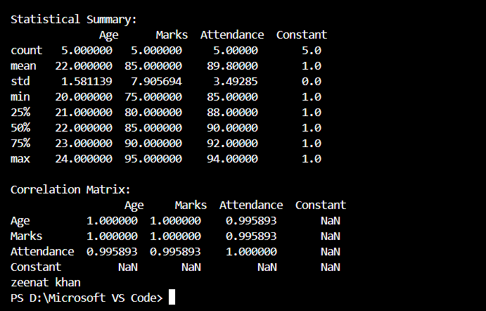
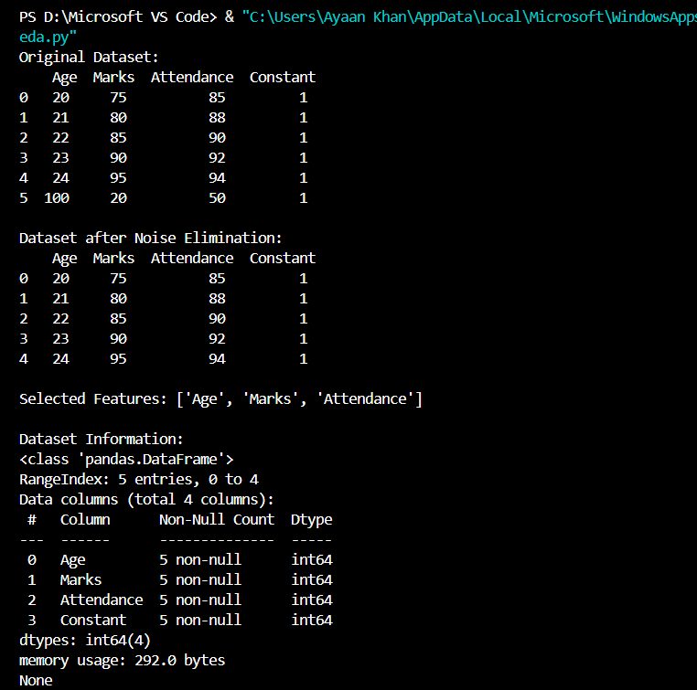

Practical 2: Designing a Relational Database and Performing CRUD using SQL
Aim
To design a relational database for a small application (a Student–Course system) and perform Create, Read, Update, and Delete (CRUD) operations using SQL.
Input (Code)
import sqlite3

conn = sqlite3.connect("college.db")
cur = conn.cursor()

# CREATE: tables
cur.executescript("""
DROP TABLE IF EXISTS Students;
DROP TABLE IF EXISTS Courses;
DROP TABLE IF EXISTS Enrollments;

CREATE TABLE Students (
student_id INTEGER PRIMARY KEY AUTOINCREMENT,
name TEXT NOT NULL,
email TEXT UNIQUE,
age INTEGER
);
CREATE TABLE Courses (
course_id INTEGER PRIMARY KEY AUTOINCREMENT,
title TEXT NOT NULL,
credits INTEGER
);
CREATE TABLE Enrollments (
enroll_id INTEGER PRIMARY KEY AUTOINCREMENT,
student_id INTEGER REFERENCES Students(student_id),
course_id INTEGER REFERENCES Courses(course_id),
grade TEXT
);
""")

# CREATE: insert records
cur.executemany("INSERT INTO Students (name, email, age) VALUES (?, ?, ?)", [
("Asha Rao", "asha@example.com", 20),
("Ravi Kumar", "ravi@example.com", 21),
("Neha Shah", "neha@example.com", 22),
])
cur.executemany("INSERT INTO Courses (title, credits) VALUES (?, ?)", [
("Data Engineering", 4),
("Database Systems", 3),
])
cur.executemany("INSERT INTO Enrollments (student_id, course_id, grade) VALUES (?, ?, ?)", [
(1, 1, "A"), (1, 2, "B+"), (2, 1, "A-"), (3, 2, "B"),
])
conn.commit()

# READ
print("All Students:")
for row in cur.execute("SELECT * FROM Students"):
print(row)

print("\nStudents with their enrolled courses:")
cur.execute("""
SELECT s.name, c.title, e.grade
FROM Enrollments e
JOIN Students s ON s.student_id = e.student_id
JOIN Courses c ON c.course_id = e.course_id
""")
for row in cur.fetchall():
print(row)

# UPDATE
cur.execute("UPDATE Students SET age = 23 WHERE name = 'Ravi Kumar'")
conn.commit()
print("\nAfter UPDATE:")
for row in cur.execute("SELECT * FROM Students WHERE name = 'Ravi Kumar'"):
print(row)

# DELETE
cur.execute("DELETE FROM Enrollments WHERE grade = 'B'")
conn.commit()
print("\nAfter DELETE (grade='B' rows removed):")
for row in cur.execute("SELECT * FROM Enrollments"):
print(row)

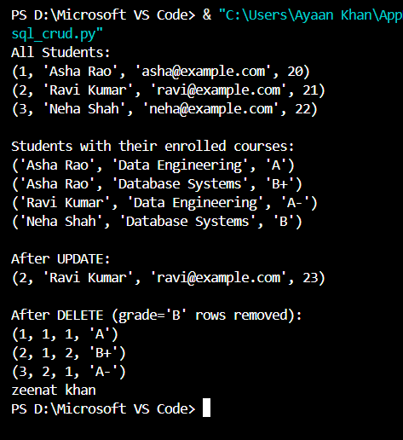
conn.close()

Practical 3: CRUD Operations in MongoDB (NoSQL)
Aim
To perform single and multiple document insertion and retrieval using the MongoDB shell (mongosh), as a NoSQL counterpart to the relational CRUD in Practical 2.
Input (Query (mongosh))
// Step 1: Insert a single document
db.items.insertOne({ name: "laptop", price: 999 });

// Step 2: View the inserted document
db.items.find();

// Step 3: Insert multiple documents
db.products.insertMany([
{ name: "phone", price: 500, stock: 10 },
{ name: "tablet", price: 300, stock: 5 },
{ name: "watch", price: 150, stock: 0 }
]);

// Step 4: View products in formatted JSON
db.products.find().pretty();

// Step 5: Update a document
db.products.updateOne({ name: "watch" }, { $set: { stock: 25 } });

// Step 6: Delete a document
db.products.deleteOne({ name: "table// Step 1: Insert a single document
db.items.insertOne({ name: "laptop", price: 999 });

// Step 2: View the inserted document
db.items.find();

// Step 3: Insert multiple documents
db.products.insertMany([
{ name: "phone", price: 500, stock: 10 },
{ name: "tablet", price: 300, stock: 5 },
{ name: "watch", price: 150, stock: 0 }
]);

// Step 4: View products in formatted JSON
db.products.find().pretty();

// Step 5: Update a document
db.products.updateOne({ name: "watch" }, { $set: { stock: 25 } });

// Step 6: Delete a document
db.products.deleteOne({ name: "tablet" });
t" });
// Step 1: Insert a single document
db.items.insertOne({ name: "laptop", price: 999 });

// Step 2: View the inserted document
db.items.find();

// Step 3: Insert multiple documents
db.products.insertMany([
{ name: "phone", price: 500, stock: 10 },
{ name: "tablet", price: 300, stock: 5 },
{ name: "watch", price: 150, stock: 0 }
]);

// Step 4: View products in formatted JSON
db.products.find().pretty();

// Step 5: Update a document
db.products.updateOne({ name: "watch" }, { $set: { stock: 25 } });

// Step 6: Delete a document
db.products.deleteOne({ name: "tablet" });
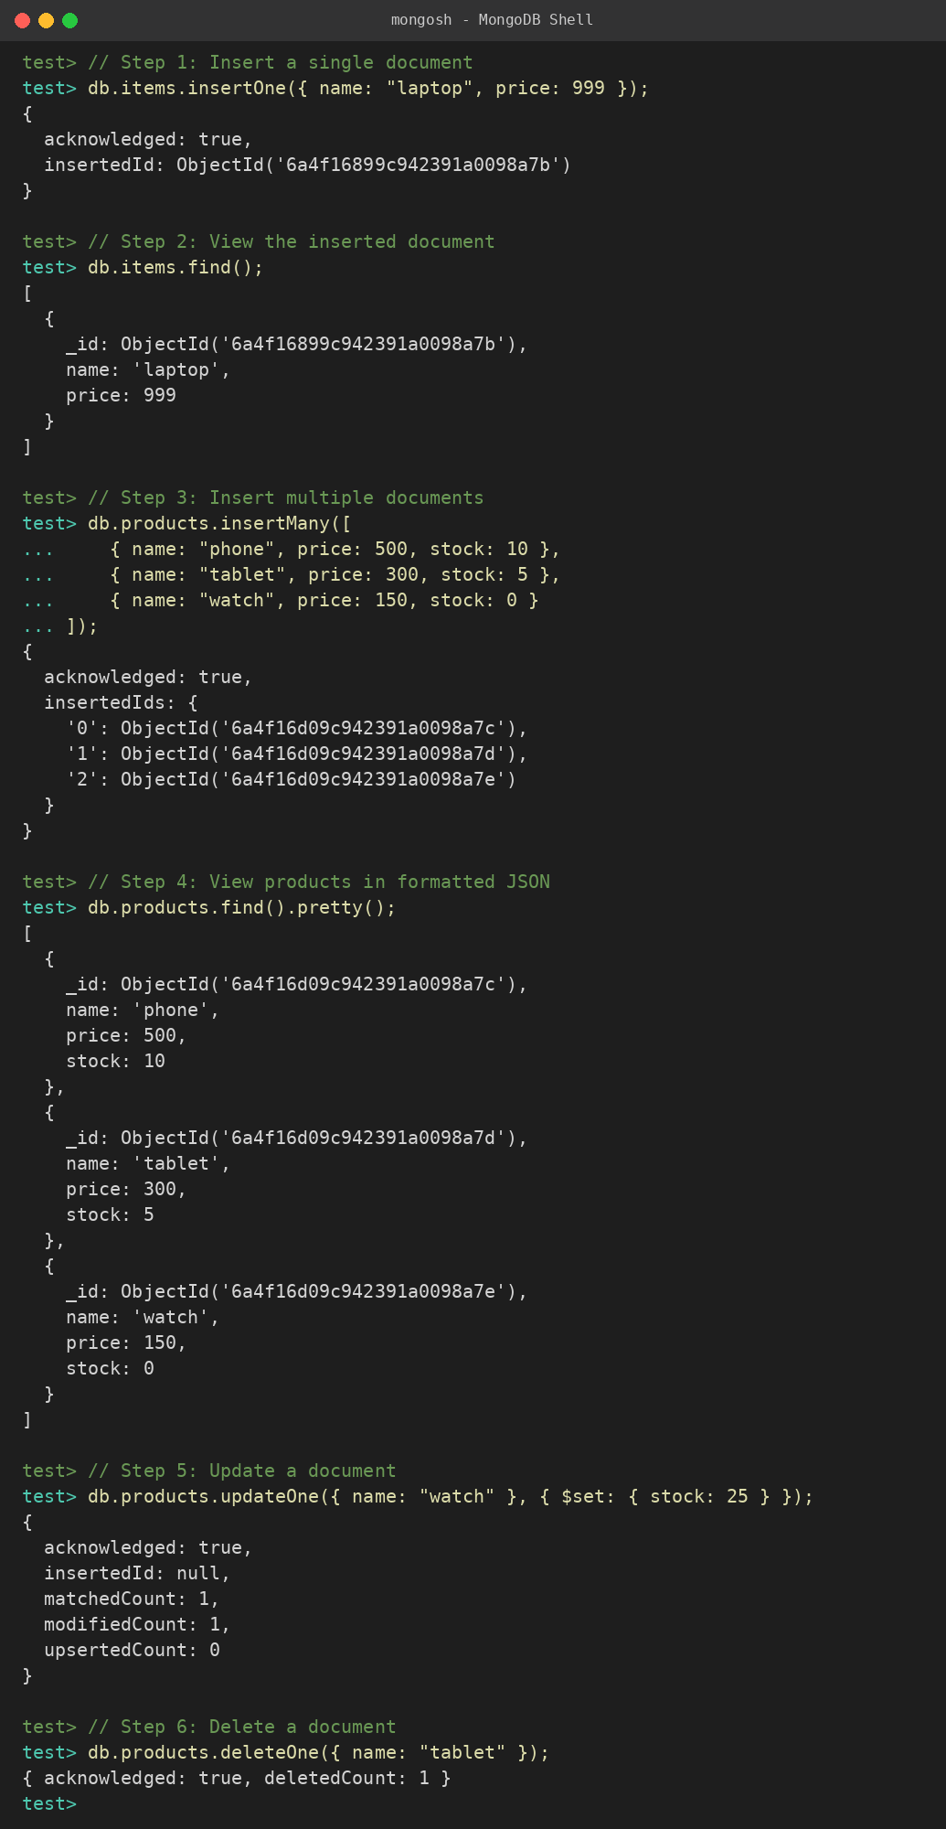

Practical 4: Extracting Data from APIs and Flat Files
Aim
To fetch user data from a public REST API, clean it, and merge it with a flat CSV file containing location details.
Input (Code (data_extraction.py))
import pandas as pd
import requests

def extract_api_data(url):
"""Fetches data from a REST API and returns a DataFrame."""
try:
response = requests.get(url, timeout=10)
response.raise_for_status()
data = response.json()
return pd.json_normalize(data) # Normalize JSON into a flat table
except requests.exceptions.RequestException as e:
print(f"API Error: {e}")
return pd.DataFrame()

def extract_csv_data(file_path):
"""Reads a flat CSV file."""
try:
return pd.read_csv(file_path)
except FileNotFoundError as e:
print(f"File Error: {e}")
return pd.DataFrame()

if __name__ == "__main__":
api_url = "https://jsonplaceholder.typicode.com/users"
api_df = extract_api_data(api_url)
api_df = api_df[["id", "name", "email", "company.name"]]
api_df.rename(columns={"company.name": "company"}, inplace=True)

csv_file = "locations.csv"
pd.DataFrame({
"id": list(range(1, 11)),
"city": ["New York", "London", "Paris", "Tokyo", "Berlin",
"Delhi", "Sydney", "Moscow", "Cairo", "Beijing"],
}).to_csv(csv_file, index=False)
csv_df = extract_csv_data(csv_file)

if not api_df.empty and not csv_df.empty:
merged_df = pd.merge(api_df, csv_df, on="id", how="inner")
print("\n--- Merged ETL Pipeline Data View ---")
print(merged_df.head())
merged_df.to_csv("cleaned_warehouse_profiles.csv", index=False)
print("\nData successfully saved to 'cleaned_warehouse_profiles.csv'")

print("\nMissing values per column:\n", merged_df.isnull().sum())
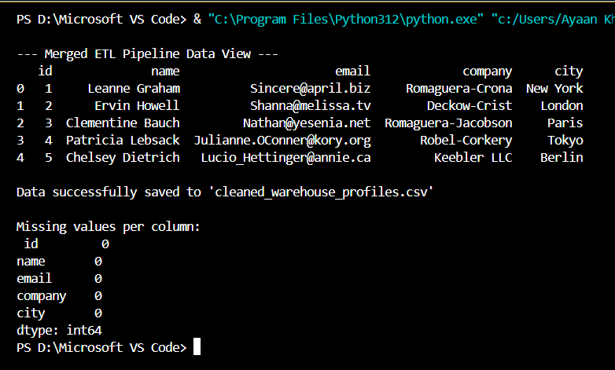

Practical 5: Setting up Apache Airflow and Creating a DAG
Aim
To configure a Directed Acyclic Graph (DAG) in Apache Airflow that runs daily, executing a start notifier, an extraction script, and a pipeline-success logger in sequence.
Input (Code (~/airflow/dags/data_pipeline_dag.py))
from datetime import datetime, timedelta
from airflow import DAG
from airflow.operators.bash import BashOperator
from airflow.operators.empty import EmptyOperator

default_args = {
"owner": "data_engineering_lab",
"depends_on_past": False,
"start_date": datetime(2026, 1, 1),
"email_on_failure": False,
"email_on_retry": False,
"retries": 1,
"retry_delay": timedelta(minutes=5),
}

with DAG(
"university_etl_orchestration",
default_args=default_args,
description="Lab assignment for API and Flat File ETL orchestration",
schedule_interval=timedelta(days=1),
catchup=False,
) as dag:

start_pipeline = EmptyOperator(task_id="start_pipeline")

execute_extraction = BashOperator(
task_id="run_extraction_script",
bash_command="python3 /absolute/path/to/data_extraction.py",
)

pipeline_complete = BashOperator(
task_id="log_pipeline_success",
bash_command='echo "ETL Execution completed successfully at $(date)"',
)

start_pipeline >> execute_extraction >> pipeline_complete
Commands to Run (Terminal)
airflow dags list
airflow tasks test university_etl_orchestration start_pipeline 2026-01-01
airflow tasks test university_etl_orchestration run_extraction_script 2026-01-01
airflow tasks test university_etl_orchestration log_pipeline_success 2026-01-01
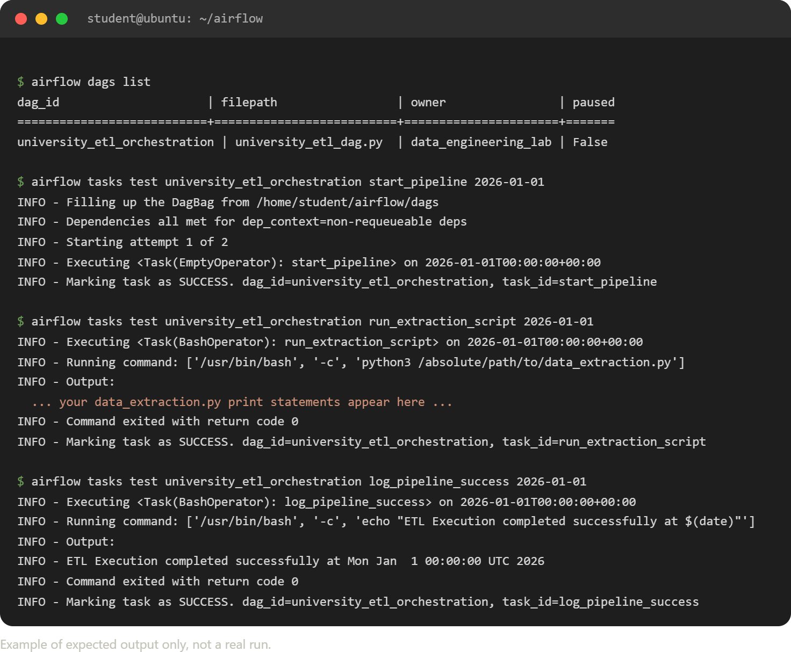

Practical 6: ETL Pipeline Design (CSV/JSON, Validation & Incremental Load)
Aim
To design an ETL pipeline that (a) extracts data from multiple CSV files and combines them, (b) extracts JSON data and loads selected fields into a relational database, (c) removes invalid records, (d) validates data before loading, and (e) supports incremental loading.
Input (Code)
import pandas as pd
import sqlite3
import json
import os

DB_FILE = "warehouse.db"

def extract_multiple_csv(file_list):
frames = [pd.read_csv(f) for f in file_list if os.path.exists(f)]
return pd.concat(frames, ignore_index=True) if frames else pd.DataFrame()

def extract_json(file_path):
with open(file_path) as f:
raw = json.load(f)
df = pd.json_normalize(raw)
return df[["order_id", "customer_name", "amount"]]

def clean_invalid(df):
df = df.dropna(subset=["order_id", "amount"])
df = df[df["amount"] > 0]
df = df.drop_duplicates(subset="order_id")
return df

def validate(df, required_cols):
missing = [c for c in required_cols if c not in df.columns]
if missing:
raise ValueError(f"Validation failed - missing columns: {missing}")
if df.empty:
raise ValueError("Validation failed - no records to load")
print(f"Validation passed: {len(df)} records ready to load.")
return True

def incremental_load(df, table_name, key_col):
conn = sqlite3.connect(DB_FILE)
try:
existing_ids = pd.read_sql(
f"SELECT {key_col} FROM {table_name}", conn)[key_col].tolist()
except Exception:
existing_ids = []
new_rows = df[~df[key_col].isin(existing_ids)]
if not new_rows.empty:
new_rows.to_sql(table_name, conn, if_exists="append", index=False)
print(f"Incremental load: {len(new_rows)} new record(s) inserted "
f"(skipped {len(df) - len(new_rows)} already-loaded record(s)).")
conn.close()

if __name__ == "__main__":
# Sample source files
jan = pd.DataFrame({"order_id": [1, 2], "customer_name": ["A", "B"],
"amount": [100, 200]})
feb = pd.DataFrame({"order_id": [3, 4], "customer_name": ["C", "D"],
"amount": [-50, 300]})
jan.to_csv("orders_jan.csv", index=False)
feb.to_csv("orders_feb.csv", index=False)

combined = extract_multiple_csv(["orders_jan.csv", "orders_feb.csv"])
print("Combined CSV data:\n", combined)

cleaned = clean_invalid(combined)
print("\nAfter removing invalid records:\n", cleaned)

validate(cleaned, ["order_id", "customer_name", "amount"])

incremental_load(cleaned, "orders", "order_id") # 1st run: inserts
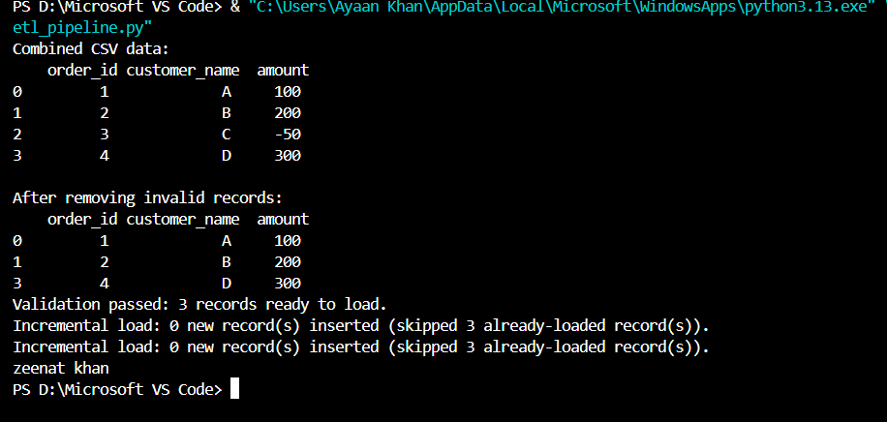
incremental_load(cleaned, "orders", " order_id") # 2nd run: skips

Practical 7: PySpark – Schema, Filtering, Grouping, Deduplication, Joins & Aggregation
Aim
To read a CSV dataset in PySpark, display its schema, perform filtering/grouping/aggregation, remove duplicate records, join two datasets, and calculate average sales by product category.
Input (Code)
from pyspark.sql import SparkSession
from pyspark.sql import functions as F

spark = SparkSession.builder.appName("DataEngineeringLab").getOrCreate()

sales_data = [
(1, "Laptop", "Electronics", 55000, 2),
(2, "Phone", "Electronics", 20000, 5),
(3, "Phone", "Electronics", 20000, 5), # duplicate row
(4, "Shirt", "Clothing", 800, 10),
(5, "Jeans", "Clothing", 1500, 4),
(6, "Sofa", "Furniture", 25000, 1),
]
columns = ["order_id", "product", "category", "price", "quantity"]
sales_df = spark.createDataFrame(sales_data, columns)

# Write to CSV and read it back
sales_df.write.mode("overwrite").option("header", True).csv("sales_csv")
csv_df = spark.read.option("header", True).option("inferSchema", True).csv("sales_csv")

# Display schema
csv_df.printSchema()

# Filtering
high_value = csv_df.filter(csv_df.price > 1000)
high_value.show()

# Grouping and aggregation
category_totals = csv_df.groupBy("category").agg(
F.sum(csv_df.price * csv_df.quantity).alias("total_sales")
)
category_totals.show()

# Remove duplicates
deduped = csv_df.dropDuplicates(["product", "category", "price", "quantity"])
deduped.show()

# Join with a second dataset
discounts = spark.createDataFrame(
[("Electronics", 10), ("Clothing", 20), ("Furniture", 5)],
["category", "discount_pct"]
)
joined = deduped.join(discounts, on="category", how="left")
joined.show()

# Average sales by category
avg_sales = deduped.groupBy("category").agg(
F.avg(deduped.price * deduped.quantity).alias("avg_sales")
)
avg_sales.show()

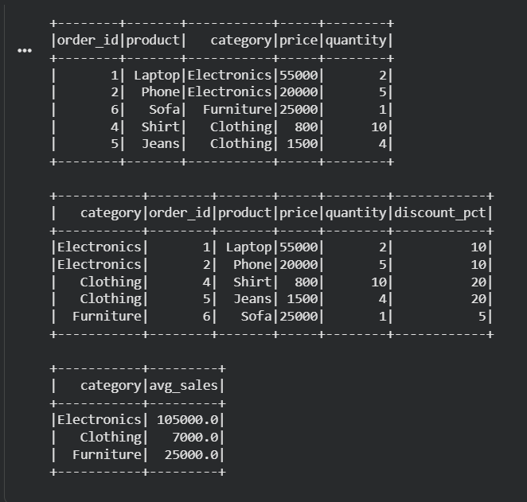
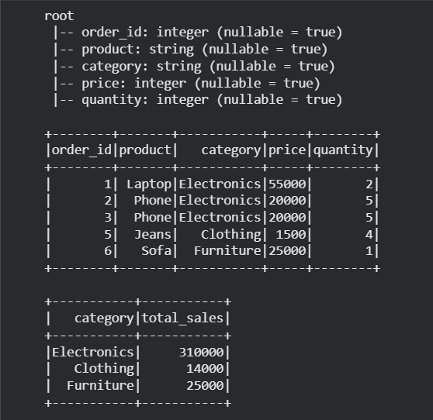
spark.stop()

Practical 8: End-to-End E-commerce ETL Pipeline (CSV → Pandas → SQL → Report)
Aim
To build an end-to-end ETL pipeline for an e-commerce dataset (customers, orders, products, payments), producing a cleaned SQL database and a summary report, while handling both historical and newly-arriving data.
Input (Code)
import pandas as pd
import sqlite3
from datetime import datetime

DB_FILE = "ecommerce.db"

# ---------- EXTRACT ----------
customers = pd.DataFrame({
"customer_id": [1, 2, 3],
"name": ["Asha", "Ravi", "Neha"],
"city": ["Mumbai", "Delhi", "Pune"],
})
products = pd.DataFrame({
"product_id": [101, 102, 103],
"product_name": ["Laptop", "Phone", "Headphones"],
"category": ["Electronics", "Electronics", "Accessories"],
})
orders_historical = pd.DataFrame({
"order_id": [1, 2],
"customer_id": [1, 2],
"product_id": [101, 102],
"order_date": ["2026-01-05", "2026-01-06"],
"quantity": [1, 2],
})
orders_new = pd.DataFrame({
"order_id": [3, 4],
"customer_id": [3, 1],
"product_id": [103, 102],
"order_date": ["2026-01-20", "2026-01-21"],
"quantity": [3, 1],
})
payments = pd.DataFrame({
"order_id": [1, 2, 3, 4],
"amount": [55000, 40000, 4500, 20000],
"status": ["Paid", "Paid", "Pending", "Paid"],
})

# ---------- TRANSFORM ----------
def clean(df):
return df.drop_duplicates().dropna()

orders_all = pd.concat([orders_historical, orders_new], ignore_index=True)
orders_all["order_date"] = pd.to_datetime(orders_all["order_date"])

merged = (clean(orders_all)
.merge(clean(customers), on="customer_id", how="left")
.merge(clean(products), on="product_id", how="left")
.merge(clean(payments), on="order_id", how="left"))

# ---------- LOAD ----------
conn = sqlite3.connect(DB_FILE)
merged.to_sql("fact_orders", conn, if_exists="replace", index=False)

# ---------- REPORT ----------
report = pd.read_sql("""
SELECT city, category, SUM(amount) AS revenue, COUNT(*) AS orders
FROM fact_orders
WHERE status = 'Paid'
GROUP BY city, category
ORDER BY revenue DESC
""", conn)
print("Revenue Report (Paid Orders):\n", report)

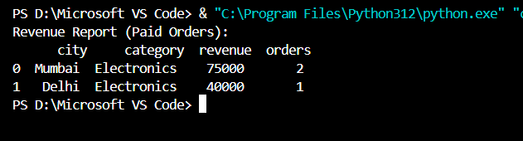
conn.close()

Practical 9: Mini Project – End-to-End Data Engineering Solution (Individual)
Aim
To design and implement a complete data engineering solution covering ingestion, cleaning, transformation, storage, data-warehouse design, and reporting for a retail sales dataset.
Architecture: Raw CSV/API sources → Staging (Pandas) → Cleaning & Transformation → Star-schema Data Warehouse (SQLite) → Reporting layer (SQL views / charts)
Input (Code)
import pandas as pd
import sqlite3

DB_FILE = "retail_dw.db"

# ---------- INGEST ----------
sales_raw = pd.DataFrame({
"txn_id": [1, 2, 3, 4, 5],
"date": ["2026-02-01", "2026-02-01", "2026-02-02", "2026-02-02", None],
"store": ["Mumbai", "Pune", "Mumbai", "Delhi", "Pune"],
"product": ["Laptop", "Phone", "Laptop", "Tablet", "Phone"],
"amount": [55000, 20000, 55000, None, 21000],
})

# ---------- CLEAN ----------
sales = sales_raw.dropna(subset=["date", "amount"]).drop_duplicates(subset="txn_id").copy()
sales["date"] = pd.to_datetime(sales["date"])

# ---------- TRANSFORM (Star Schema) ----------
dim_store = sales[["store"]].drop_duplicates().reset_index(drop=True)
dim_store["store_id"] = dim_store.index + 1

dim_product = sales[["product"]].drop_duplicates().reset_index(drop=True)
dim_product["product_id"] = dim_product.index + 1

fact_sales = (sales
.merge(dim_store, on="store")
.merge(dim_product, on="product"))[
["txn_id", "date", "store_id", "product_id", "amount"]]

# ---------- LOAD ----------
conn = sqlite3.connect(DB_FILE)
dim_store.to_sql("dim_store", conn, if_exists="replace", index=False)
dim_product.to_sql("dim_product", conn, if_exists="replace", index=False)
fact_sales.to_sql("fact_sales", conn, if_exists="replace", index=False)

# ---------- REPORT ----------
report = pd.read_sql("""
SELECT s.store, SUM(f.amount) AS total_revenue, COUNT(*) AS transactions
FROM fact_sales f
JOIN dim_store s ON s.store_id = f.store_id
GROUP BY s.store
ORDER BY total_revenue DESC
""", conn)
print("Store-wise Revenue Report:\n", report)

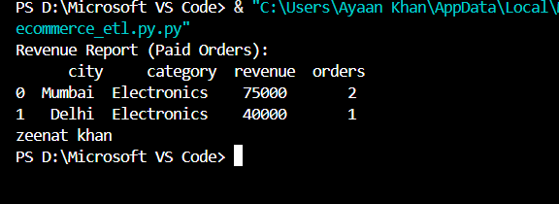
conn.close()

Practical 10: Mini Project – End-to-End Data Engineering Solution (Group of 2)
Aim
As a group of two, design and implement a complete data-engineering solution — data ingestion, cleaning, transformation, storage, data-warehouse design, and reporting — for a larger, jointly-chosen dataset, dividing responsibilities between both members.
Project Plan & Role Split
Team Member A – Ingestion & Cleaning
- Source the dataset (CSV / public API / Kaggle dataset)
- Write ingestion scripts (extract_api.py / extract_csv.py)
- Handle missing values, duplicates, and data-type corrections
- Output: cleaned_data.csv
Team Member B – Transformation, Warehouse & Reporting
- Design a star schema (fact + dimension tables) from the cleaned data
- Load into a database (SQLite / PostgreSQL) using the incremental-load pattern from Practical 6
- Build the reporting layer: SQL views / a small Pandas + Matplotlib or Power BI dashboard summarizing key metrics
Joint Work
- Orchestrate the full pipeline with an Airflow DAG (as in Practical 5) chaining: ingest → clean → transform → load → report
- Document the architecture diagram and prepare the final presentation
Input (Orchestration Code (Joint))
from datetime import datetime, timedelta
from airflow import DAG
from airflow.operators.python import PythonOperator

def ingest():
print("Member A: extracting and cleaning raw data...")

def transform_load():
print("Member B: transforming into star schema and loading warehouse...")

def report():
print("Joint: generating final summary report...")

default_args = {
"owner": "team",
"start_date": datetime(2026, 1, 1),
"retries": 1,
"retry_delay": timedelta(minutes=5),
}

with DAG("group_mini_project_pipeline", default_args=default_args,
schedule_interval="@daily", catchup=False) as dag:

t1 = PythonOperator(task_id="ingest_and_clean", python_callable=ingest)
t2 = PythonOperator(task_id="transform_and_load", python_callable=transform_load)
t3 = PythonOperator(task_id="generate_report", python_callable=report)

t1 >> t2 >> t3
Deliverables for submission: cleaned dataset, warehouse schema diagram (fact/dimension tables), the Airflow DAG script, the reporting output (table/chart/dashboard screenshot), and a short write-up describing each member's contribution.

